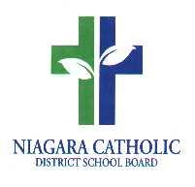
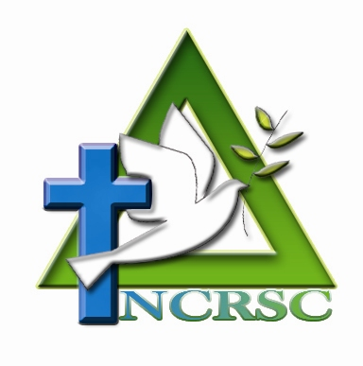
CALL FOR NOMINATIONS
NIAGARA CATHOLIC PARENT INVOLVEMENT COMMITTEE (NCPIC)
PARENT/GUARDIAN MEMBERSHIP 2020-2021

The Niagara Catholic Parent Involvement Committee (NCPIC) supports the Mission of Catholic Education and the Mission, Vision and Values of the Niagara Catholic District School Board, by providing a communication link to parents/guardians, Catholic School Councils, the Diocese, the Director of Education, and the Board.
The NCPIC promotes active parent/guardian engagement within all schools for the improvement of student achievement and the well-being of all students in the Niagara Catholic District School Board.
The NCPIC membership is made up of parents/guardians, community and student representatives, the Bishop of the Diocese of St. Catharines or his appointed representative, Principals, teachers, and support staff, the Director of Education or Designate, the appointed Superintendent of Education, and Trustees. The Niagara Catholic Parent Involvement Committee meets on the second Thursday of the month, on a bi-monthly basis at the Catholic Education Centre from 6:30 p.m. to 8:30 p.m.

Parent/Guardian Membership
To be eligible for election/appointment as a parent/guardian representative to the Niagara Catholic Parent Involvement Committee, a person:
- must be a parent/guardian of a student enrolled in a Niagara Catholic District School Board school
- must reside within the Board’s jurisdiction,
- must support the Mission, Vision and Values of the Niagara Catholic District School Board, and
- must fully participate in the Annual Commissioning Ceremony of NCPIC members.
Available parent/guardian positions for the 2020-2021 Niagara Catholic Parent Involvement Committee Membership:
Fort Erie/Port Colborne/Wainfleet | 1 position | Parent/Guardian Representatives
Grimsby/Lincoln/West Lincoln/Pelham | 1 position | Parent/Guardian Representatives
Niagara Falls/Niagara-on-the-Lake | 2 positions | Parent/Guardian Representatives
St. Catharines | 3 positions | Parent/Guardian Representatives
Thorold/Merritton | 1 position | Parent/Guardian Representative
Welland | 1 position | Parent/Guardian Representatives

Interested parents/guardians are to complete and submit the parent/guardian nomination form no later than 4:00 p.m. EST., on Friday, October 9, 2020. Nomination forms are available at the school and on the Board website, or by clicking on the link: Niagara Catholic Parent Involvement Committee.

Please send nomination forms to: Catholic Education Centre
427 Rice Road
Welland, ON L3C 7C1
Attention: Yvonne Anderson
or by email to: yvonne.anderson@ncdsb.com

NIAGARA CATHOLIC PARENT INVOLVEMENT COMMITTEE
PARENT/GUARDIAN NOMINATION FORM
FOR THE 2020-2021 SCHOOL YEAR

□ I have read and agree to the Eligibility of Membership of the Niagara Catholic Parent Involvement
Committee and wish to declare my candidacy for an elected position as a parent/guardian
representative on the Niagara Catholic Parent Involvement Committee.

Name: _____________________________________________________________________________

Address: ____________________________________________________________________________

Home Telephone No. _______________________ Business Telephone No.______________________

E-mail: _____________________________________________________________________________

I am the parent/guardian of _________________________________________________, who is/are
(Student(s) name)
currently enrolled at ___________________________________________________________________.
(Name of School (s))

I am declaring my candidacy for the area of:

- Fort Erie/Port Colborne/Wainfleet | - St. Catharines
- Grimsby/Lincoln/West Lincoln/Pelham | - Thorold/Merritton
- Niagara Falls/Niagara-on-the-Lake | - Welland

Candidate’s Signature ____________________________________ Date: ________________________________

Please describe in a few sentences how you would like to contribute to the Niagara Catholic Parent Involvement Committee: ______________________________________________________________________________________________________________________________________________________________________________________________________________________________________________________________________________________________________________________________________________________________________________________________________________________________________________________________________________________________________________________________
_____________________________________________________________________________________
Please send nomination forms to: Catholic Education Centre
427 Rice Road
Welland, ON L3C 7C1
Attention: Yvonne Anderson
or by email to: yvonne.anderson@ncdsb.com

Complete nomination forms must be received no later than 4:00 p.m. EST., on Friday, October 9, 2020.

